*Florida International University*

*School of Computing and Information Sciences*

Software Engineering Focus

Feature Document

User Story #**138**

**Team Member:**

Pierre Jimenez

**Product Owner(s)**:

Mohsen Taheri

**Mentor(s)**:

Mohsen Taheri

**Instructor**: Masoud Sadjadi

**User Story** Create Database Schema

* As a database modeler, I want to create a database schema so that I can save all pertinent information about a user and their assignments

Acceptance Criteria

* Database schema should be able to house personal user information and assignment information

**Use Case** #**138 – Create Database Schema**

**Class Diagram**

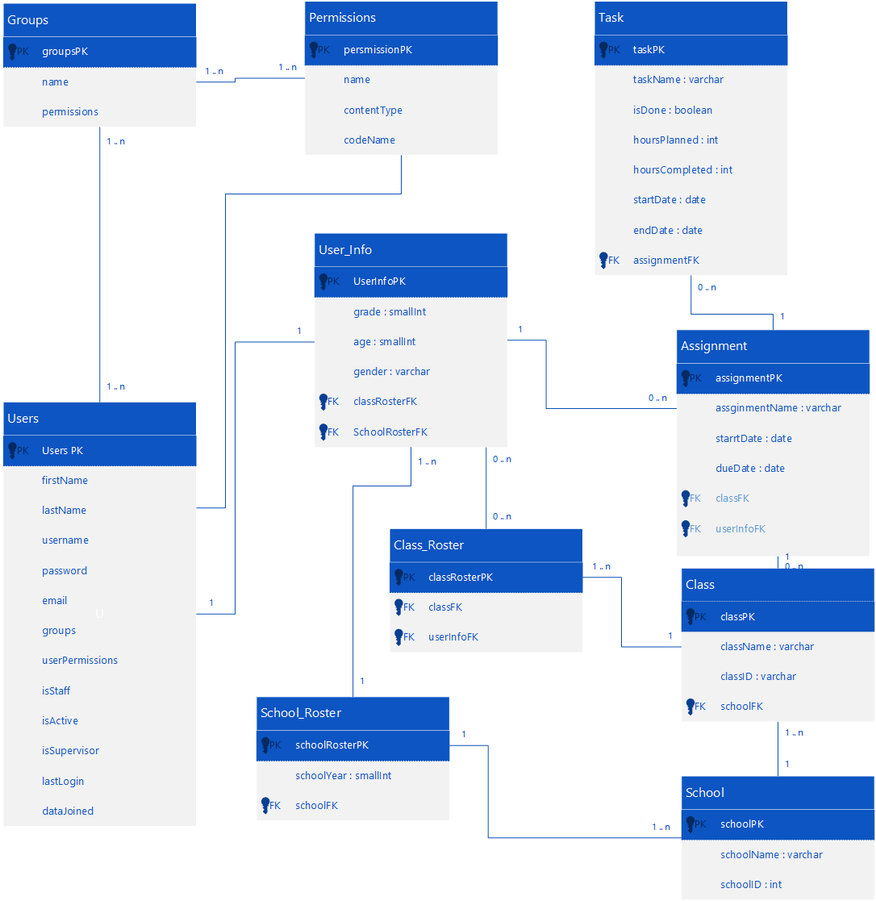

**Unit Test**

**Test Case 1 (Sunny Day)**

**Purpose**

* Check that the default startdate cannot be before today. startDate has a default value of today if none is placed.

**Precondition**

* All fields are filled with valid information

**Input**

* startDate

**Expected Result**

* startDate is greater than or equal today’s date

**Actual Result**

* Assignment gets created.

**Visual User Guide**